Install PyCharm

1. Open the browser and <https://www.jetbrains.com/pycharm/download/?section=windows>
2. This is Pycharm official site
3. Scroll and select Pycharm community edition

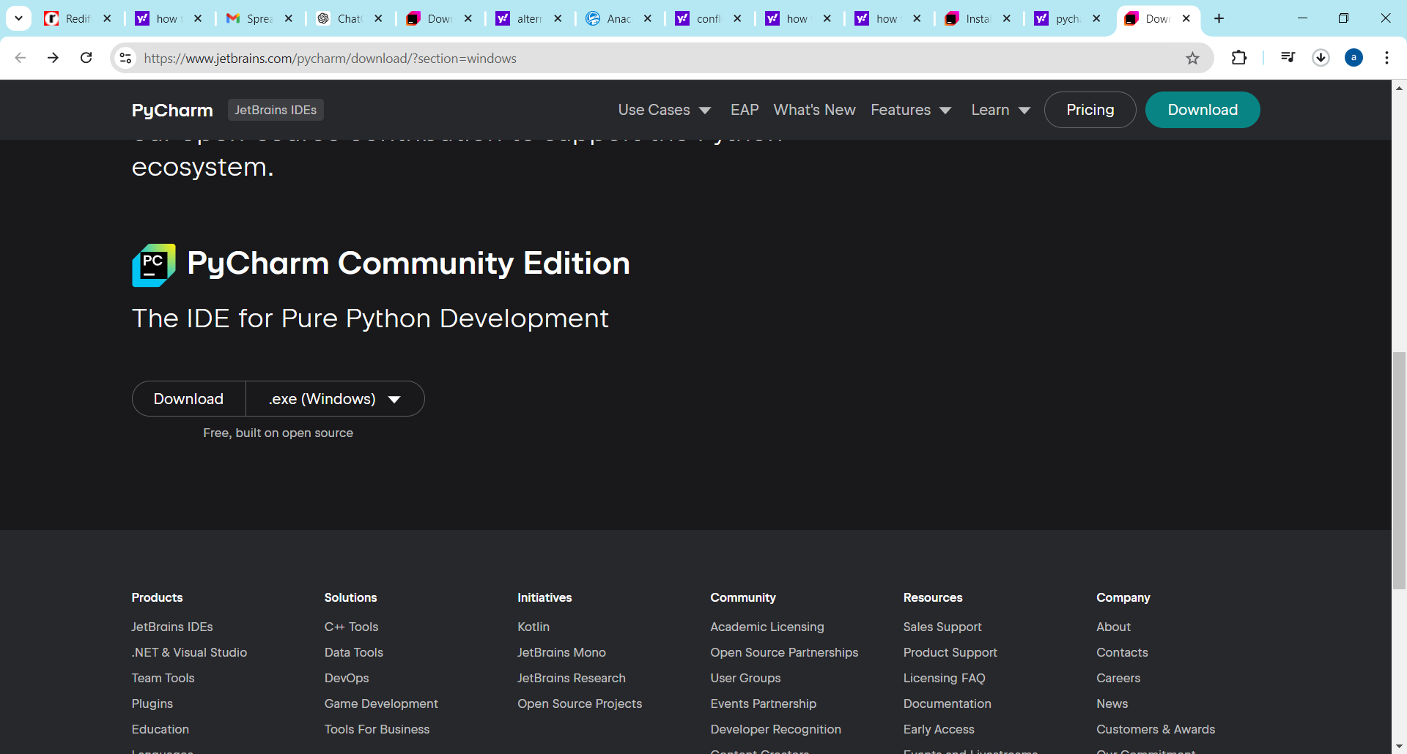

1. Download it according to your operating system
2. Run the installer
3. After installation you will receive